

COMPUTER SCIENCE

PROJECT

TITLE OF PROJECT

BANK MANGEMENT SOFTWARE

SUBMITTED BY
[PAARTH SINGH]
Class – XII S1
Roll No –

GURUKUL THE SCHOOL
NH24, GHAZIABAD
CERTIFICATE

This is to certify that Paarth Singh of class XII S1, Roll No has completed Computer Science Project under my supervision and guidance as per the latest curriculum of Central Board of Secondary Education (2022-2023).

Ms. Sandhya Singh

[Teacher In-charge] Institution Stamp

ACKNOWLEDGEMENT

I express my deep sense of gratitude and indebtedness to my Computer Science teacher Ms. Sandhya Singh for her liberal and wholehearted support to me in the completion of this project.

I sincerely acknowledge the co-operation extended to me by school management. I express my thanks to the Principal Mr. Gaurav Bedi and all the faculty members of Gurukul The School, Ghaziabad who extended their active support throughout my schooling.

I solicit my deepest regards to my parents and friends who encouraged me a lot throughout my class XII course.

CONTENTS

Title Page No.

1. Summary / Objective 6
2. System Specifications 7
3. Program Code 8
4. Program working/output 16
5. Debugging Process 20
6. BIBLIOGRAPHY 21

OBJECTIVE

A computer based system developed & designed to handle primary information and very basic functionality of banking system.

The BANK MANAGEMENT SYSTEM undertaken as a project is based on relevant technologies. This project has been developed to carry out the processes easily and quickly, which is not possible with the manual systems, which are overcome by this application. This project is developed using Python language. It will reduce clerical work as most of the work done by computer. It provides greater speed and reduced time consumption.

HARDWARE & SOFTWARE SPECIFICATIONS

- Hardware Requirements
Core i3, 8 GB RAM, 500 GB Hard Disk

- Software Requirements
Windows 10 or above
Python 3.9
Visual studio code

Program Code

import pickle
import os

def startProgram():
print("\t-----------------")
print("\tBANKING SYSTEM")
print("\t-----------------")

def writeAccount():
AcNo= int(input("Enter account no : "))
name = input("Enter account holder name : ")
amount = int(input("Enter Initial amount :"))
l=[AcNo,name,amount]
writeAccountsFile(l)
print("\n Account Created")

def displayAll():
f = open('accounts.data','rb')
mylist = pickle.load(f)
for item in mylist :
print(item[0]," ", item[1], " ",item[2] )
f.close()

def displaySp(num):
f = open('accounts.data','rb')
mylist = pickle.load(f)
f.close()
found = False
for item in mylist :
if int(item[0]) == num :
print("Your account Balance is = ",item[2])
found = True
if not found :
print("No existing record with this number")

def deposit(num1):
file = pathlib.Path("accounts.data")
if file.exists ():
f = open('accounts.data','rb')
mylist = pickle.load(f)
f.close()
os.remove('accounts.data')
for item in mylist :
if int(item[0]) == num1 :
amount = int(input("Enter amount to deposit : "))
b=int(item[2])
item[2] = b + amount
print("Rs. " , amount, " has been deposited in Your account No:", num1 )
else :
print("No records to Search")
newfile = open('newaccounts.data','wb')
pickle.dump(mylist,newfile)
newfile.close()
os.rename('newaccounts.data', 'accounts.data')

def Withdraw(num1):
f = open('accounts.data','rb')
mylist = pickle.load(f)
f.close()
os.remove('accounts.data')
for item in mylist :
if int(item[0]) == num1 :
amount = int(input("Enter amount to withdraw : "))
if amount <= int(item[2]) :
b=int(item[2])
item[2] = b – amount
print("Rs. " , amount, " has been withdrawn from Your account No:", num1)
print("Balance amount is Rs. ", item[2])
else :
print("You cannot withdraw larger amount")

newfile = open('newaccounts.data','wb')
pickle.dump(mylist, newfile)
newfile.close()
os.rename('newaccounts.data', 'accounts.data')

def deleteAccount(num):
f = open('accounts.data','rb')
oldlist = pickle.load(f)
f.close()
newlist = []
for item in oldlist :
if item[0] != num :
newlist.append(item)
os.remove('accounts.data')
newfile = open('newaccounts.data','wb')
pickle.dump(newlist, newfile)
newfile.close()
os.rename('newaccounts.data', 'accounts.data')

def modifyAccount(num):
f = open('accounts.data','rb')
oldlist = pickle.load(f)
f.close()
os.remove('accounts.data')
for item in oldlist :
if item[0] == num :
item[1] = input("Enter account holder name : ")

newfile = open('newaccounts.data','wb')
pickle.dump(oldlist, newfile)
newfile.close()
os.rename('newaccounts.data', 'accounts.data')

def writeAccountsFile(data) :
file = pathlib.Path("accounts.data")
if file.exists ():
f = open('accounts.data','rb')
oldlist = pickle.load(f)
oldlist.append(data)
f.close()
os.remove('accounts.data')
else :
oldlist = [data]
newfile = open('newaccounts.data','wb')
pickle.dump(oldlist, newfile)
newfile.close()
os.rename('newaccounts.data', 'accounts.data')

# starting point of program
ch=''
num=0
startProgram ()
while ch != 8:
print("\OPTIONS")
print("\t1. OPEN ACCOUNT")
print("\t2. DEPOSIT")
print("\t3. WITHDRAW")
print("\t4. BALANCE ENQUIRY")
print("\t5. ALL ACCOUNT LIST")
print("\t6. CLOSE ACCOUNT")
print("\t7. MODIFY ACCOUNT")
print("\t8. EXIT")
print("\tSelect Your Option from 1 To 8 ")
ch = input()
os.system("cls");

if ch == '1':
writeAccount()
elif ch =='2':
num = int(input("\tEnter account No. : "))
deposit(num)
elif ch == '3':
num = int(input("\tEnter account No. : "))
Withdraw(num)
elif ch == '4':
num = int(input("\tEnter account No. : "))
displaySp(num)
elif ch == '5':
displayAll();
elif ch == '6':
num =int(input("\tEnter account No. : "))
deleteAccount(num)
elif ch == '7':
num = int(input("\tEnter account No. : "))
modifyAccount(num)
elif ch == '8':
print("Exiting banking application")
break
else :
print("Not a valid choice")

Program Working / Output

- Main Screen
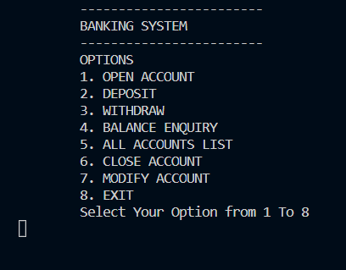

- New Account (1)
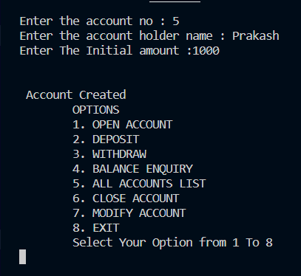

- Deposit amount (2)
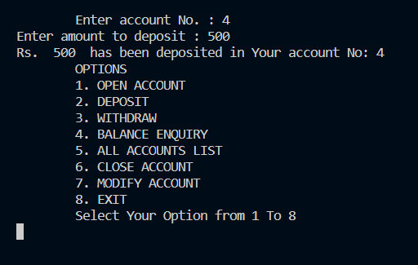

- Withdraw amount (3)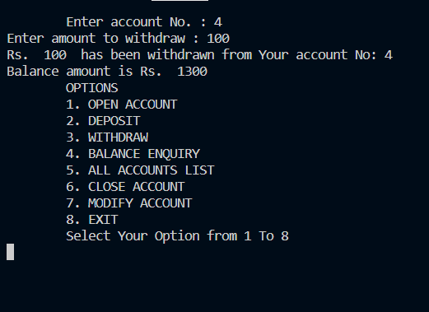

- Check Balance (4)
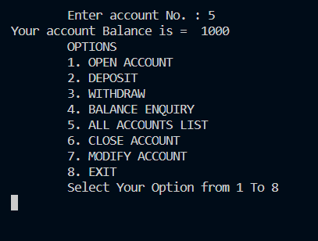

- Show All accounts (5)
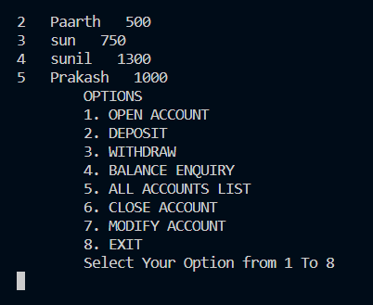

- Close Account (6)
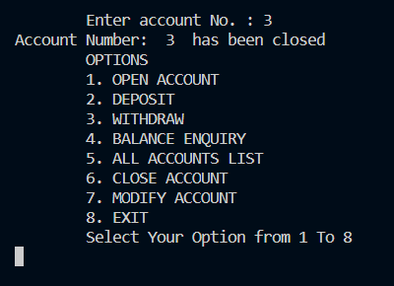

- Modify Account Name (7)
Before change After Modify
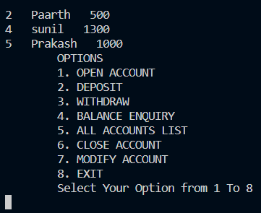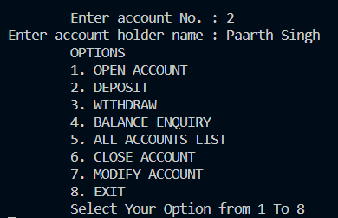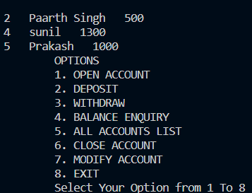

- Exit Application (8)
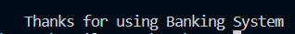

DEBUGGING PROCESS

Debugging is an important part of project development.
The debugging process adopted in the development of this project is testing of each function.
Each functionality and method is written and tested individually to verify that every function is working correctly. All the functions are tested together to get the desired output.

BIBLIOGRAPHY

- Computer Science with Python
–Sumita Arora

- CBSE All In One Computer Science with Python - Neetu Gaikwad

- https://www.learnpython.org/
- https://www.python.org/
- https://www.w3schools.com/python/

